# **Purpose of this document**

The purpose of this document is to investigate the sample data provided in the ML Foundation Nanodegree project : “Test a Perceptual Phenomenon”.

The answer to each question asked in the project assignment has been provided in the following section.

**Investigation**

Q1. What is our independent variable? What is our dependent variable?

Ans : The **independent variable** is the congruency of the words, i.e. whether the words displayed actually match the color of ink.

The **dependent variable** is the reaction time of the participant, i.e. time taken to name all the ink colors in a pre-defined list.

Q2. What is an appropriate set of hypotheses for this task? What kind of statistical test do you expect to perform? Justify your choices.

Ans : The **hypothesis** for this study is that - participants will take longer time to name all the ink colors when the words displayed do not match the ink color.

**Mathematically**, the hypothesis is :

**Null hypothesis** (H0) : μI ≤ μC

**Alternate hypothesis** (HA) : μI > μC

where,

* μI is the population mean reaction time for incongruent word condition (words do not match ink color)
* μC is the population mean reaction time for congruent word condition (words match ink color)

**Type of statistical test :** Dependent one-tailed t-test for paired samples of type ‘repeated measures design’.

**Reasons for choosing the above test :**

1. The population parameters (mean and SD) are not known, only the sample parameters are known, hence t-test is done instead of z-test.
2. The same subject takes the test twice, hence it is a dependent test.
3. There are two different conditions (congruent and incongruent), hence the type is ‘two condition test’ (i.e. repeated measures design).
4. There is a specific direction in the hypothesis (incongruent reaction times need to be greater), hence it is a one-tailed test.

Q3. Report some descriptive statistics regarding this dataset. Include at least one measure of central tendency and at least one measure of variability.

Ans : The following are the descriptive statistics for this dataset :

|  |  |  |
| --- | --- | --- |
|  | **Congruent Sample** | **Incongruent Sample** |
| **Measures of Centrality** |  |  |
| Mean | 14.05 | 22.02 |
| Median | 14.36 | 21.02 |
|  |  |  |
| **Measures of Variability** |  |  |
| Range | 13.70 | 19.57 |
| Variance | 12.67 | 23.01 |
| Standard Deviation | 3.56 | 4.80 |

Q4. Provide one or two visualizations that show the distribution of the sample data. Write one or two sentences noting what you observe about the plot or plots.

Ans : The following three graphs help to visualize the sample data :

**Visualization 1 : Histogram of congruent sample (bucket size = 2)**

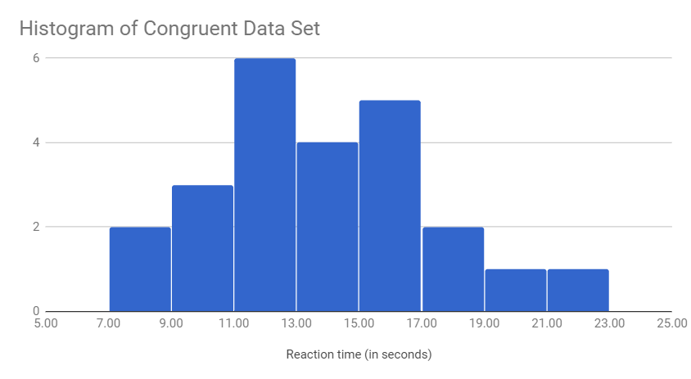

**Observation :** The above histogram shows that the distribution is approximately normal with a slight positive skewness.

**Visualization 2 : Histogram of incongruent sample (bucket size = 2)**

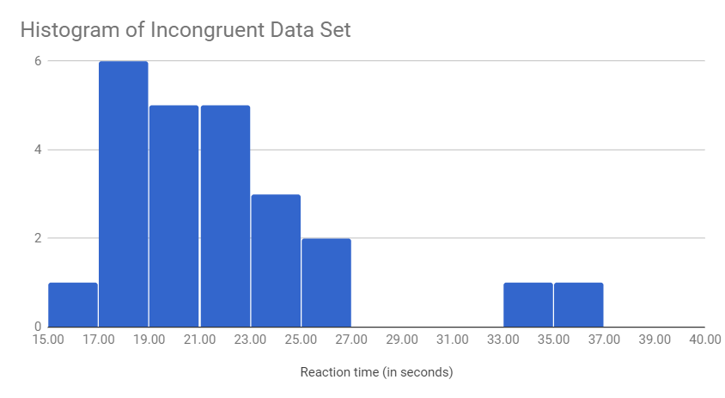

**Observation :** The above histogram shows that the distribution is approximately normal with a large positive skewness.

**Visualization 3 : Stacked area chart for congruent and incongruent conditions**

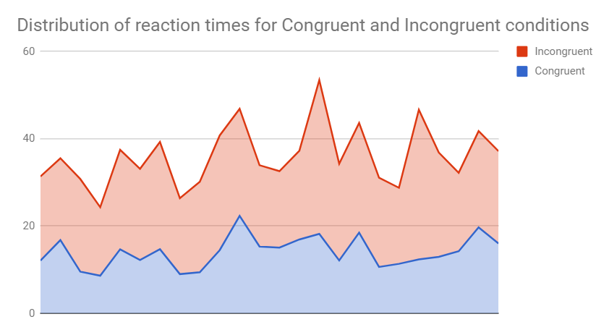

**Observation :** The above chart gives an indication that incongruent reaction times might be higher than that of congruent reaction times. This hypothesis needs to be tested for statistical significance.

Q5. Now, perform the statistical test and report your results. What is your confidence level and your critical statistic value? Do you reject the null hypothesis or fail to reject it? Come to a conclusion in terms of the experiment task. Did the results match up with your expectations?

Ans : **Results of the dependent one-tailed t-test for the paired sample :**

* t(23) = 8.02, p < .00005, one-tailed
* α = 0.05
* Confidence Interval on the mean difference; 95% CI = (5.91 , 10.02)
* t* = 1.714

Hence, we can **reject the null hypothesis**. The results are extremely statistically significant.

**Conclusion :**  The reaction time is longer for the incongruent condition compared to the congruent condition. In other words, when the displayed words do not match the ink color, it takes longer to complete the test.

**Expectations of the result :** These results are in accordance with the Stroop Effect.

Q6. Optional: What do you think is responsible for the effects observed? Can you think of an alternative or similar task that would result in a similar effect? Some research about the problem will be helpful for thinking about these two questions!

Ans : The effect observed (i.e. longer reaction time for incongruent conditions) can be attributed to the reason that a **participant must overcome the initial and stronger stimuli to read** the word. The brain automatically understands the meaning of words as a result of habitual reading and this conflicts with the manual operation of trying to parse the color of the word.

**Proposal for an alternative task :** Participants can be asked to hear a sound denoting the color and a congruent / incongruent colored square is displayed on the screen. It might be interesting to analyze which has a bigger effect on increasing reaction times - incongruent words or incongruent sounds.

**External resources**

* Stroop, J. R. (1935). Studies of interference in serial verbal reactions
* <https://en.wikipedia.org/wiki/Stroop_effect>
* <https://www.psytoolkit.org/lessons/stroop.html>
* <https://faculty.washington.edu/chudler/java/strvote.html>